SIMATS ENGINEERING
ASSESSMENT TOOL 1

COURSE NAME: Artificial Intelligence COURSE CODE: CSA17

COURSE OUTCOME COVERED

CO1: Apply AI basics such as intelligent agents and uninformed search methods to solve problems effectively. (BL3)

Assessment Tool Weightage: 35%

QUESTIONS: 5 Duration : 1 Hour
Total Marks:50

Annexure A

Analytical Problem Solving

Code of Conduct:

I S.K.Deepa Arathi / 192571020 (Name / Reg No) certify that this submission is my original work and that I have adhered to the guidelines specified for this assessment.
I understand that any violation of academic integrity rules will result in disciplinary action.

Signature of the student:

Annexure A

Analytical Problem Solving

- Solve the Water Jug problem: you are given 2 jugs, a 4-gallon one and 3-gallon one. Neither has any measuring maker on it. There is a pump that can be used to fill the jugs with water. How can you get exactly 2 gallons of water into 4-gallon jug? Explicit assumptions: A jug can be filled from the pump, water can be poured out of a jug onto the ground, water can be poured from one jug to another and that there are no other measuring devices available.

- Find out how Mars Rover, analyse and explore the samples on Mars by answering the following questions.
- What are the percept’s for this agent?
- Characterize the operating environment.
- What are the actions the agent can take?
- How can one evaluate the performance of the agent?
- What sort of agent architecture do you think is most suitable for this agent? Why?

- Explore the search space using search strategies and formulate the problem components for the 8-Queens problem using the following information: Place 8 queens on a chessboard such that none of the queen’s attack any of the others. A configuration of 8 queens on the board as shown in the figure below, but this does not represent a solution as the queen in the first column is on the same diagonal as the queen in the last column.

- A customer wants to travel from the one location to another location using OLA Cab booking mobile application. The customer can select the any of the cab type as mini, micro, sedan, shared, prime and so on based on his comfort to reach the destination. Identify what type of problem-solving agent can be used and write the pseudocode for the above problem.

- A logistics company operates a delivery network where packages must be transported between warehouses at minimum cost. Each route between warehouses has an associated travel cost (fuel + time). The company wants to determine the least-cost path from the starting warehouse S to the destination warehouse G using the Uniform Cost Search (UCS) algorithm.

The delivery network is represented as a weighted graph:


RUBRICS FOR CALCULATION:
Criteria | Weightage | Level 4 (Exemplary) | Level 3 (Proficient) | Level 2 (Developing) | Level 1 (Beginning)
Problem Understanding | 20% | Clearly interprets problem, identifies all parameters and requirements accurately | Understands problem with minor gaps | Partial understanding; misses key elements | Misinterprets or unable to understand problem
Method Selection | 20% | Selects most appropriate method/formula with strong justification | Selects correct method with minor errors | Inappropriate or partially correct method | Unable to select method
Solution Process | 25% | Logical, systematic steps with correct approach throughout | Mostly correct steps with minor mistakes | Disorganized steps; multiple errors | No clear process
Accuracy of Calculation | 20% | All calculations accurate; correct final answer | Minor calculation errors | Frequent errors; incorrect final answer | No valid calculations
Interpretation of Results | 15% | Clearly interprets results with units and engineering relevance | Basic interpretation with minor omissions | Limited or unclear interpretation | No interpretation
Problem Understanding | 20% | Clearly interprets problem, identifies all parameters and requirements accurately | Understands problem with minor gaps | Partial understanding; misses key elements | Misinterprets or unable to understand problem

Question 1: Water Jug Problem
Q. Using a 4-gallon and a 3-gallon jug (no markings) and a pump, get exactly 2 gallons into the 4-gallon jug.
1.1 Understanding the problem
We have two unmarked jugs, so the only way to know how much water we hold is to fill a jug completely, empty it completely, or pour until the receiving jug is full or the source jug is empty. I represent every situation as a pair (x, y), where x is the water in the 4-gallon jug and y is the water in the 3-gallon jug. The start state is (0, 0) and the goal is any state of the form (2, y).
Problem formulation
• State space: (x, y) with 0 ≤ x ≤ 4 and 0 ≤ y ≤ 3 (20 possible states)
• Initial state: (0, 0) Goal state: (2, y) for any y
• Operators: fill a jug, empty a jug, pour one jug into the other until the target is full or the source is empty
• Path cost: one unit per action (so a shorter sequence is a better one)

1.2 Operators used
No. | Operator | Condition / effect
R1 | Fill the 4-gallon jug | (x, y) → (4, y), if x < 4
R2 | Fill the 3-gallon jug | (x, y) → (x, 3), if y < 3
R3 | Empty the 4-gallon jug on the ground | (x, y) → (0, y), if x > 0
R4 | Empty the 3-gallon jug on the ground | (x, y) → (x, 0), if y > 0
R5 | Pour 3-gallon jug into 4-gallon jug until it is full | (x, y) → (4, y − (4 − x)), if x + y ≥ 4 and y > 0
R6 | Pour 4-gallon jug into 3-gallon jug until it is full | (x, y) → (x − (3 − y), 3), if x + y ≥ 3 and x > 0
R7 | Pour all of the 3-gallon jug into the 4-gallon jug | (x, y) → (x + y, 0), if x + y ≤ 4 and y > 0
R8 | Pour all of the 4-gallon jug into the 3-gallon jug | (x, y) → (0, x + y), if x + y ≤ 3 and x > 0

1.3 Solution – step by step
Step | Action taken | 4-gal (x) | 3-gal (y) | Rule
0 | Start with both jugs empty | 0 | 0 | –
1 | Fill the 3-gallon jug from the pump | 0 | 3 | R2
2 | Pour the 3-gallon jug into the 4-gallon jug | 3 | 0 | R7
3 | Fill the 3-gallon jug again | 3 | 3 | R2
4 | Pour into the 4-gallon jug until it is full (only 1 gallon fits) | 4 | 2 | R5
5 | Empty the 4-gallon jug on the ground | 0 | 2 | R3
6 | Pour the 2 gallons from the 3-gallon jug into the 4-gallon jug | 2 | 0 | R7

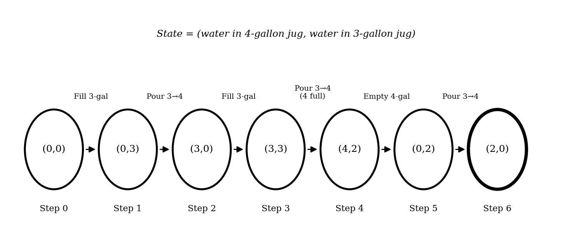
Figure 1: State-space path from (0,0) to the goal (2,0)
Result: After 6 actions the 4-gallon jug holds exactly 2 gallons, so the goal is reached.
Another route that also works in 6 actions: fill 4-gal → pour into 3-gal (1,3) → empty 3-gal (1,0) → pour 4-gal into 3-gal (0,1) → fill 4-gal (4,1) → pour into 3-gal (2,3). Here too the 4-gallon jug ends with 2 gallons.

Question 2: Mars Rover – Agent Analysis
Q. Identify percepts, environment, actions, performance measure and a suitable architecture for a rover that explores Mars and analyses samples.
A Mars rover is a good example of a real intelligent agent. It has to sense a harsh, unknown planet, decide what to do on its own (a radio signal takes several minutes to travel between Earth and Mars, so nobody can steer it live) and act with moving parts such as wheels and a robotic arm. The usual way to describe such an agent is the PEAS framework (Performance, Environment, Actuators, Sensors).
2.1 PEAS description at a glance
PEAS element | Description
P – Performance | Number and scientific value of samples analysed, area explored, safe travel (no falls, no getting stuck), efficient use of battery and time, data successfully sent to Earth, mission lifetime
E – Environment | Rocky and sandy Martian terrain, slopes, craters, dust storms, extreme cold, low sunlight at times, delayed communication with Earth
A – Actuators | Wheels and steering motors, robotic arm, drill / scoop, sample-handling tray, camera mast, antenna, solar panel and heater controls
S – Sensors | Stereo cameras, spectrometers, soil/rock analyser, temperature and wind sensors, gyroscope and wheel encoders, sun sensor, battery monitor, radio receiver

2.2 Percepts – what the rover senses
Percept group | Examples
Visual | Camera images of terrain, rocks, craters and possible obstacles
Scientific | Chemical composition from spectrometer, mineral type, presence of water or organic traces in a sample
Physical surroundings | Temperature, wind speed, dust level, sunlight intensity
Self-status | Position and tilt, wheel slip, battery charge, arm position, instrument health, memory left
Communication | Commands and new targets uploaded from Earth control

2.3 Characterising the operating environment
Property | Type | Reason
Observable | Partially | Cameras see only a limited range; the ground below the surface and far areas are hidden
Agents | Single agent | The rover works alone; there are no competing agents
Determinism | Stochastic | Wheel slip, sand and dust make the result of a move uncertain
Episodic / Sequential | Sequential | Current moves affect later options (battery, position, sample queue)
Static / Dynamic | Dynamic | Weather, light and dust change while the rover is thinking
Discrete / Continuous | Continuous | Positions, speeds and sensor values vary smoothly
Known / Unknown | Largely unknown | Much of the terrain has never been seen before

2.4 Actions the agent can take
Category | Actions
Movement | Move forward / backward, turn left / right, stop, climb or avoid slope, choose a new route
Sampling | Take photos, scrape or drill a rock, scoop soil, place it into the analyser
Analysis | Run spectrometer, record readings, compare with earlier samples
Housekeeping | Recharge using solar panels, switch on heaters, go into sleep mode in storms
Communication | Send data to Earth, receive new commands, re-aim antenna

2.5 Evaluating the performance of the agent
Measure | What is checked
Scientific return | How many useful samples were analysed and how accurate the results were
Coverage | Area or distance explored per day against the plan
Safety | Number of hazards avoided; no damage, tip-over or stuck wheels
Resource use | Energy used per task, idle time, memory and bandwidth used
Reliability | Days of working life and tasks finished without human help

2.6 Most suitable agent architecture
Recommended: a goal-based agent with utility-based decision making (model-based, with a simple reflex layer for safety).
• Model-based: the world is only partly visible, so the rover must keep an internal map and remember where it has already been.
• Goal-based: it has clear goals (reach a target rock, collect and analyse a sample) and must plan a sequence of actions for them.
• Utility-based: when goals conflict (a promising rock far away versus low battery), a utility value lets it choose the best trade-off.
• Reflex layer: emergency rules such as “tilt too high → stop” react instantly without planning.
• Why not a pure reflex agent? It cannot plan ahead or deal with unseen areas, and because of the communication delay Earth cannot remote-control it in real time.

Question 3: 8-Queens Problem – Formulation and Search
Q. Formulate the problem components and explore the search space for placing 8 queens so that none attacks another.
3.1 Understanding the problem
We must place eight queens on an 8 × 8 chessboard so that no two share the same row, column or diagonal. The configuration in the question is not a solution because the queen in the first column and the queen in the last column lie on the same diagonal, so they attack each other. A valid arrangement needs every queen to be safe from all others.
3.2 Problem components (incremental formulation)
Component | Definition
States | Any arrangement of 0 to 8 queens on the board in which no two queens attack each other
Initial state | Empty board (no queen placed)
Actions | Place a queen in the leftmost empty column, in a row where it is not attacked by queens already placed
Transition model | Returns the board with the new queen added
Goal test | 8 queens are on the board and none is attacked
Path cost | Not important – only the final arrangement matters (each placement can be taken as cost 1)

3.3 Size of the search space
Formulation | Number of states | Remark
Complete-state: any 8 queens on any squares | ≈ 1.8 × 10¹⁴ | Huge, impractical
One queen per column (permutations) | 8! = 40,320 | Much smaller
Incremental with no attacks (used here) | 2,057 | Best for search

The incremental formulation prunes every attacked square immediately, so the search never wastes time on boards that are already wrong. This is why it shrinks the problem from billions of states to just a couple of thousand.
3.4 Exploring the space with search strategies
Strategy | How it behaves on 8-Queens | Verdict
Breadth-First Search | Explores all boards with k queens before k + 1; needs to store a very large frontier | Correct but memory-hungry
Depth-First Search / Backtracking | Places one queen per column, goes deeper, and backs up when a column has no safe row | Best choice – low memory, all solutions lie at depth 8
Depth-Limited Search (limit 8) | Same as DFS but stops at depth 8 | Equally suitable

I choose depth-first search with backtracking. All solutions lie at the same depth (8), the memory needed is only the current board, and any dead end is abandoned quickly. In total the puzzle has 92 solutions, of which only 12 are fundamentally different once rotations and reflections are ignored.
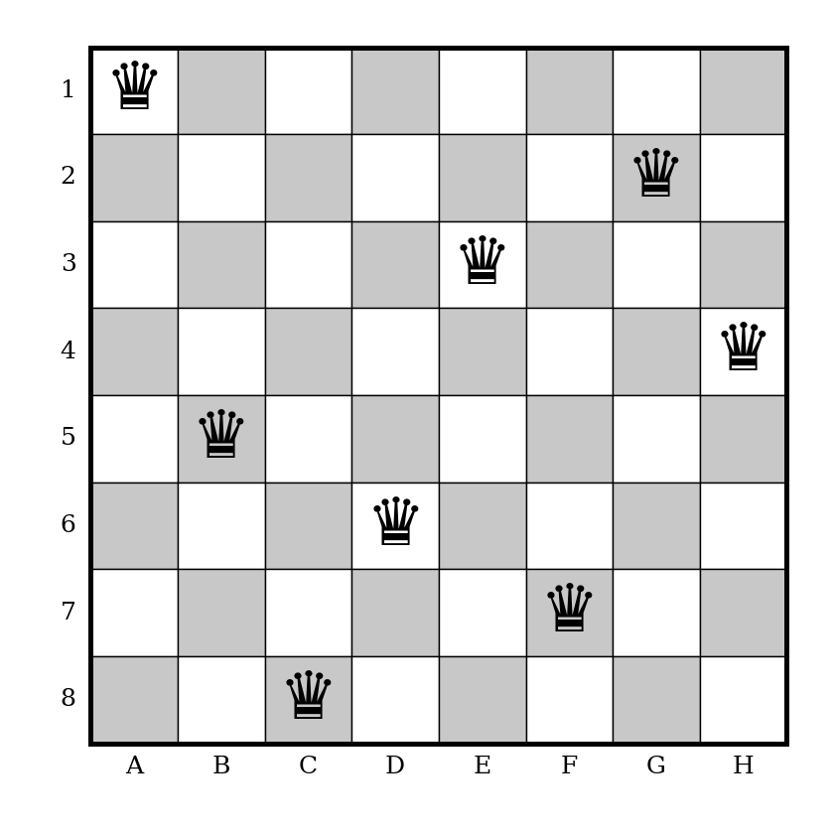
Figure 2: One valid solution – A1, B5, C8, D6, E3, F7, G2, H4
Check: each row and each column has exactly one queen, and no two queens share a diagonal (their row difference is never equal to their column difference), so the goal test is satisfied.

Question 4: OLA Cab Booking – Problem-Solving Agent
Q. Identify the type of problem-solving agent and write pseudocode for choosing a cab type and reaching the destination.
4.1 Type of agent
When a customer opens the OLA app, a pick-up point and a destination are given, and the cab category (Micro, Mini, Prime Sedan, Shared and so on) is chosen according to comfort and price. The app does not simply react to one input; it looks ahead, compares options and aims at a specific result – a safe ride to the destination. So the best fit is a goal-based problem-solving agent, which also uses a utility function to rank the cab types (fare, waiting time, comfort).
Component | OLA cab booking
Initial state | Customer at the pick-up location, no cab booked
Goal state | Customer at the destination
Percepts | Pick-up / drop locations, available cabs nearby, cab types, fare estimate, traffic, driver ETA
Actions | Select cab type, confirm booking, assign driver, follow route, start / end trip, pay
Path cost | Fare + travel time (+ discomfort as a penalty)
Utility | U(cab) = w₁·comfort − w₂·fare − w₃·waiting time

4.2 Pseudocode
function OLA-BOOKING-AGENT(percept) returns action
persistent: seq (action sequence, initially empty)
state, goal, problem

state <- UPDATE-STATE(state, percept)
if seq is empty then
goal <- FORMULATE-GOAL(state) // reach destination D
problem <- FORMULATE-PROBLEM(state, goal)
options <- AVAILABLE-CABS(pickup, cab types)
best <- NULL ; bestUtility <- -infinity
for each cab in options do
u <- UTILITY(cab.comfort, cab.fare, cab.eta)
if u > bestUtility then best <- cab ; bestUtility <- u
choice <- CUSTOMER-CONFIRM(best, options) // customer may override
route <- SEARCH(problem, choice) // shortest / cheapest route
seq <- [CONFIRM-BOOKING(choice), ASSIGN-DRIVER,
FOLLOW(route), END-TRIP, PAYMENT]
if route = failure then return NO-CAB-AVAILABLE
action <- FIRST(seq)
seq <- REST(seq)
return action

The agent first formulates its goal and problem, then searches for a route and the best cab, and finally carries out the resulting plan one action at a time. If no cab is available or the route fails, it reports this and the customer can pick a different category.

Question 5: Uniform Cost Search – Least-Cost Delivery Path
Q. Find the least-cost path from warehouse S to warehouse G in the weighted network using Uniform Cost Search.
5.1 Understanding the problem
The network has six warehouses (S, A, B, C, D, G). The edge labels are the delivery costs (fuel + time): S→A = 1, S→G = 12, A→B = 3, A→C = 1, B→D = 3, C→D = 1, C→G = 2 and D→G = 3. UCS always expands the node with the lowest path cost g(n) from the start, so the first time G is removed from the priority queue its cost is guaranteed to be the minimum.
5.2 Step-by-step trace
Step | Node expanded | g(n) | Frontier after expansion (node : cost) | Explored
1 | S | 0 | A:1, G:12 | S
2 | A | 1 | C:2, B:4, G:12 | S, A
3 | C | 2 | D:3, B:4, G:4 (G improved from 12 via C) | S, A, C
4 | D | 3 | B:4, G:4 (G via D would cost 6 – ignored) | S, A, C, D
5 | B | 4 | G:4 (D via B would cost 7 – ignored) | + B
6 | G | 4 | Goal reached – stop | + G

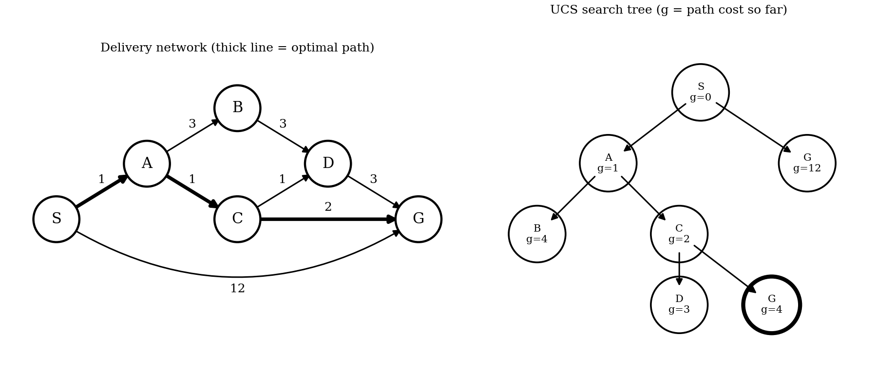
Figure 3: Delivery network and UCS search tree
5.3 Cost of every possible path
Path | Total cost | Comment
S → A → C → G | 1 + 1 + 2 = 4 | Optimal
S → A → C → D → G | 1 + 1 + 1 + 3 = 6 | Longer
S → A → B → D → G | 1 + 3 + 3 + 3 = 10 | Costly
S → G (direct) | 12 | Most expensive

Final answer: The least-cost route is S → A → C → G with a total cost of 4 units. The direct road S → G looks shortest on the map but costs three times more (12). UCS is complete and optimal for positive edge costs, so the company should dispatch its packages along S → A → C → G.

